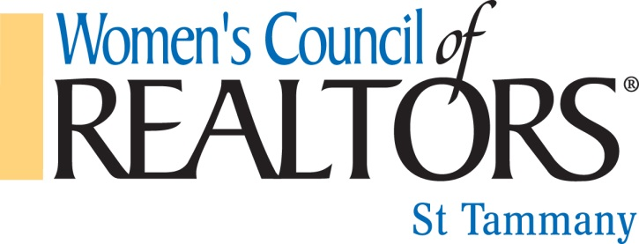
“Bras for a Cause”

Dear Friends of WCR:

The St. Tammany Chapter of the Women’s Council of REALTORS is pleased to announce that preparations are underway for our Sixth Annual Northshore “Bras for a Cause” breast cancer care fundraiser. This exciting event will be held on Thursday, October 13, 2016 from 6:00 pm – 9:00 pm at The Northshore Harbor Center. Attendees will enjoy Food, Open Bar, Music and a Live & Silent Auction. Tickets are just $50 in advance and $60 at the door.

WCR truly appreciates the help and support of our affiliates. Without your donations, our fundraising events would not be possible. We ask for your continued generosity and support. There are several ways of showing your support.

- Be a sponsor for the event with various levels ranging from $125 - $1,000 sponsorship.
- Enter a decorated bra for the “Parade of Bras” live auction with your favorite male model
- Donation of door prizes
- Donate auction items for the live auction and/or silent auction
- Raffle Tickets -2 Saints Tickets to a game, Hotel Room NOLA and $1000 CASH!!
- Silpada Jewelry, Becca Frischhertz will be having parties thru out the year Call for your Party…. donating ALL her profits back to the fundraiser!!
A portion of the proceeds will be donated to breast cancer care through the Slidell Memorial Hospital Foundation and the St. Tammany Hospital Foundation. Over $75,000 has been donated in the past 5 years!

To have your company logo/information on the official posters, flyers, social media posts, etc. you must pick a sponsorship level and provide a copy of your logo no later than June 15, 2016.

For more information, to reserve your sponsorship, buy tickets, or make a donation please contact Andrea Taft @ (985) 788-8238 or Andrea@Eustismortgage.com. You may also contact Gina Smith @ (985) 807-4030 or GSmith@myccmortgage.com.

Make checks payable to: Women’s Council of REALTORS (Tax ID#72-1149955)

We appreciate your continued support and look forward to hearing from you soon!

Sincerely,
Andrea Taft, EUSTIS Mortgage
Gina Smith, Cross Country Mortgage
Co-Chairs for Bras for a Cause Event- 2016

