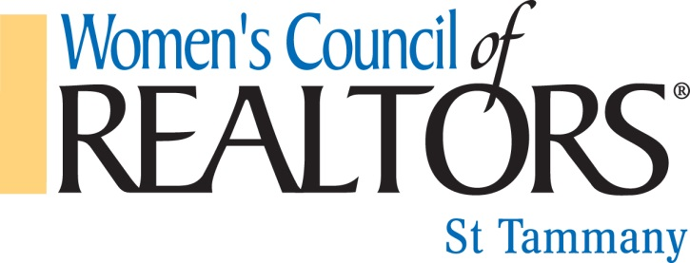
“Bras for a Cause”

Dear Friends of WCR:

The Women’s Council of Realtors® - St. Tammany is pleased to announce that preparations are underway for our 12th Annual Northshore “Bras for a Cause” fundraiser. This exciting event will be held on Thursday, October 19, 2023, from 6:00 pm – 9:00 pm at the Northshore Harbor Center. Attendees will enjoy Food, Open Bar, Music and a Live & Silent Auction. Tickets are just $60 in advance and $70 at the door.

WCR truly appreciates the help and support of our affiliates. Without your donations, our fundraising events would not be possible. We ask for your continued generosity and support. There are several ways of showing your support.

- Be a sponsor for the event with various levels ranging from $250 - $5,000 sponsorship.
- Enter a decorated bra ($150) for the “Parade of Bras” live auction with your favorite male model
- Donation of silent auction items
- Donate auction items for the live auction and/or silent auction
- Raffle Tickets -2 Saints Tickets to a game, and $500 CASH!!
- Purchase tickets for the event and help us spread the word.

A portion of the proceeds will be donated to breast cancer care through the Slidell Memorial Hospital Foundation and the St. Tammany Hospital Foundation. Over $223,000 has been donated in the past 11 years!

For more information, to reserve your sponsorship, buy tickets, or make a donation please contact Stephanie Turnage @ (985) 710-0585 sturnage@deltatitlecorp.com or Renee Ponds @ (504) 237-7737 wcrstp@gmail.com Mailing Address: 5001 Hwy 190 A-4, Covington LA 70433
.

Make checks payable to: Women’s Council of REALTORS, St. Tammany
(Tax ID#72-1149955)
We appreciate your continued support and look forward to hearing from you soon!

Sincerely,

Women’s Council of Realtors® - St. Tammany

